# [Chris Meloni reveals how his wife and kids feel about his ‘zaddy’ status](https://www.today.com/popculture/tv/chris-meloni-wife-kids-feel-zaddy-label-people-magazine-rcna51841?cid=sm_npd_td_tw_ma)

"My kids, on the other hand, invariably once a month, it’s ‘Really? Really?'" the "Law & Order: Organized Crime" star said.

TAP TO UNMUTE

Oct. 12, 2022, 12:09 PM -03 / Source: TODAY

By Anna Kaplan

In just over a year, Christopher Meloni has gone from [questioning the meaning](https://www.today.com/popculture/christopher-meloni-being-internet-s-zaddy-fame-60-t227379) of "zaddy" to fully embracing the label.

Meloni said in an [interview with People](https://people.com/tv/christopher-meloni-loves-current-career-high-becoming-zaddy-at-61-exclusive/) he's just trying to enjoy the ride of his "second act to a certain degree."

"It’s great. Are you kidding me? I’m 61-years-old and a zaddy. The lucky streak continues," he said.

Meloni has captured the internet's heart-eyes since returning to the role of [Detective Elliot Stabler](https://www.today.com/popculture/tv/olivia-benson-elliot-stabler-relationship-timeline-law-and-order-svu-rcna37289) on the "Law & Order" spinoff "Law & Order: Organized Crime" last year. (The [nude Peloton ad](https://www.today.com/popculture/popculture/chris-meloni-peloton-ad-rcna38274) and [numerous magazine covers](https://www.today.com/popculture/christopher-meloni-being-internet-s-zaddy-fame-60-t227379) displaying his ripped abs also probably had something to do with it.)

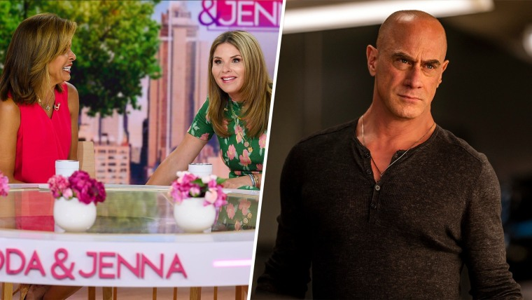

## [Hoda and Jenna react to Christopher Meloni’s Peloton ad](https://www.today.com/video/christopher-meloni-s-nude-workouts-are-on-full-display-in-new-ad-144277573923)

JULY 18, 202201:23

"It’s a gas. It’s fun. I don’t know, has anyone else been crowned Zaddy? Once it’s bestowed upon you, you have to just ride that horse as long as you can," Meloni jokingly told People.

For the record, [Merriam-Webster defines](https://www.merriam-webster.com/words-at-play/zaddy-daddy-origin-meaning-rap) a "zaddy" as someone who "seems to have that certain *je ne sais quoi* combining looks, confidence, and charm." The dictionary also notes "there is no indication that zaddy must refer exclusively to a parent."

Meloni also shared how his wife of 27 years, Sherman Williams, and their two children, Sophia, 21, and Dante, 18, have reacted to his new title.

### *Recommended*



### [PRIME DAY](https://www.today.com/shop/amazon-prime-day)[Last chance to snag smart watches, earbuds and more under-$25 Amazon Prime deals](https://www.today.com/shop/amazon-prime-day-deals-under-25-october-2022-t265122)



### [PRIME DAY](https://www.today.com/shop/amazon-prime-day)[18 picks the Shop TODAY editors are buying during Amazon's Prime Early Access Sale](https://www.today.com/shop/amazon-prime-day-early-access-sale-editors-picks-t265103)

"My wife, she’s lovely, she gets it. Meaning she’s like, 'Eh, whatever,'" he said. "My kids, on the other hand, invariably once a month, it’s 'Really? Really?' Their friends will send them a meme that’s come out or whatever."

"But I think secretly in their hearts, they get it," he continued. "It’s cool, because we all have a good goof with it. My children’s friends bust my chops, but it’s all fun. It’s an honor."

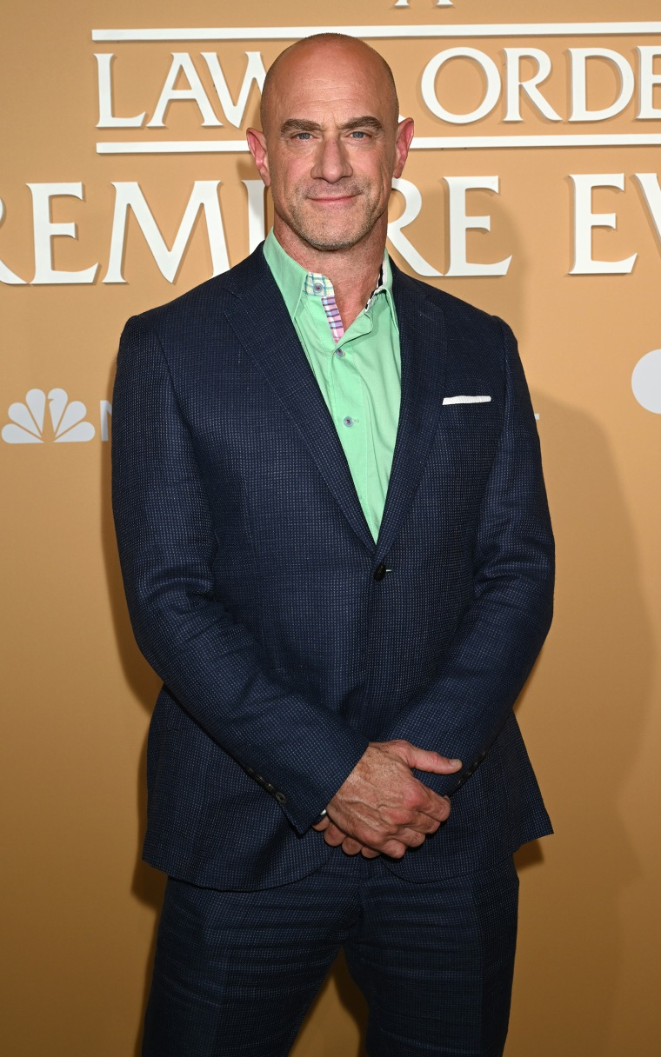Christopher Meloni at the "Law & Order Crossover Premiere Press Day" on Sept. 19, 2022.NBC / Scott Gries/NBC via Getty Images

For a [Men's Health cover story](https://www.menshealth.com/fitness/a37081725/christopher-meloni-interview-law-and-order-organized-crime/) last year, Meloni needed clarification on the meaning of "zaddy." "Daddy plus? Daddy platinum?" he asked. "I just thought it was a cutie thing."

"It’s reserved for an older gentleman," he says later. "How much am I allowed to taste of this fruit? How much am I allowed to enjoy this?"

Seems like he's still taking it all in.